40.53: a) Eq. (42-32): 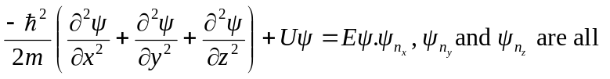
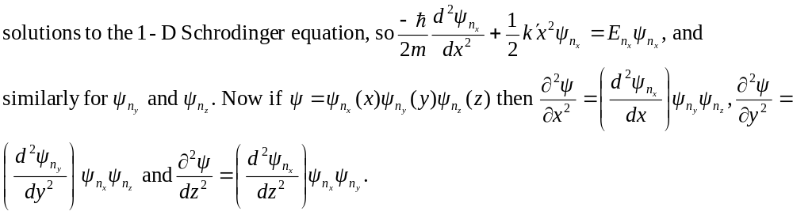Therefore:
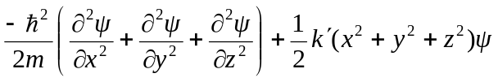
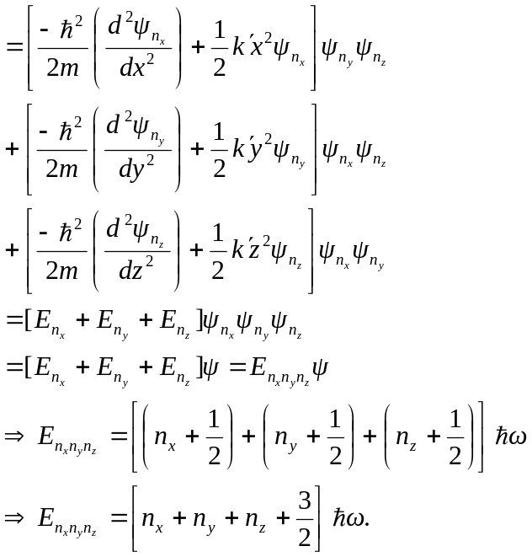
b) Ground state energy 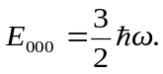
First excited state energy 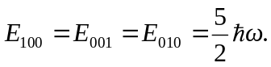
c) As seen in b) there is just one set of quantum numbers (0, 0, 0) for the ground state and three possibilities (1, 0, 0), (0, 1, 0) and (0, 0, 1) for the first excited state.

